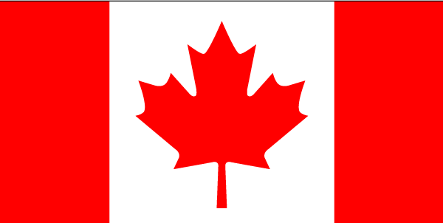 | 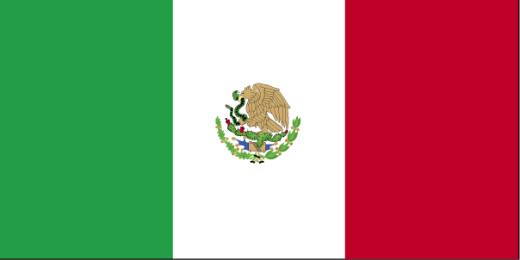

Joint Statement between the Department of the Environment of Canada and the Ministry of Environment and Natural Resources of the United Mexican States on Strengthened Dialogue and Cooperation on Climate Change

Recognizing their joint commitment to sustainable development which underpins the North American Free Trade Agreement, the Security and Prosperity Partnership for North America and the Canada-Mexico Partnership,

Building on existing cooperative mechanisms including the Agreement of Environmental Cooperation between the Government of Canada and the Government of the United Mexican States signed on March 16, 1990; the Letter of Intent for Future Collaboration on Climate Change between the Department of the Environment of Canada and the Ministry of Environment, Natural Resources and Fisheries of the United Mexican States signed on February 18, 1999; and the Letter of Intent between the Department of Foreign Affairs and International Trade of Canada and the Ministry of Environment and Natural Resources of the United Mexican States on Climate Change Initiatives, including Clean Development Mechanism Projects, signed on October 25, 2004,

Acknowledging the social, economic and security risks posed by global climate change,

Reiterating their commitment to the goals of the United Nations Framework Convention on Climate Change and its Kyoto Protocol,

The Department of the Environment of Canada and the Ministry of Environment and Natural Resources of the United Mexican States (hereinafter referred to as the “Participants”):

- reaffirm their wish to strengthen, broaden and deepen efforts to combat climate change and to support strong, sustainable growth;

- declare their intention of cooperating in international climate change negotiations with a view to developing an approach to future international cooperation based on:

  - Ensuring environmental effectiveness;
  - Providing incentives for broad participation;
  - Advancing development goals in a sustainable way;
  - Realizing the full potential of market based approaches;
  - Realizing the full power of technology; and
  - Tackling adaptation;

- confirm their mutual interest in strengthening the partnership between the two countries through enhanced cooperation in the areas of:

  - Clean Development Mechanism (hereinafter referred to as the “CDM”): to promote CDM project activities between investors and project developers from Canada and Mexico with a view to increasing the number of bilateral CDM projects and associated carbon credits;

  - Adaptation: to share information and lessons learned, to build research and training capacity, and to disseminate tools for both vulnerability assessments and for adaptation strategies to climate change;

  - Technology development and deployment opportunities: to identify clean and efficient technologies suitable for development and application in both Canada and the United Mexican States to encourage low carbon technology development, deployment, and dissemination, and, where appropriate, assess the necessary conditions for their application;

  - Raising public awareness about climate change: to share best practices and promote awareness among different stakeholders including the media, general public, private sector, non-governmental organizations, and government authorities about the causes and impacts of climate change and opportunities for greenhouse gas emission reductions;

- declare their intention of establishing a Joint Working Group on Climate Change Cooperation, hereinafter referred to as the “Climate Change Working Group” (CCWG), that would be led on the Canadian side jointly by the Department of the Environment of Canada and the Department of Foreign Affairs and International Trade, and on the Mexican side by the Ministry of Environment and Natural Resources (SEMARNAT); and

- approve the Terms of Reference for this working group annexed to this Joint Statement and declare their intention of elaborating its first work plan by May 31, 2006 and integrating them as part of this understanding. With respect to financing issues, the Participants wish to explore the role of multilateral financing instruments, the private sector, joint ventures, public-private partnerships, and the potential role of carbon finance.

The Joint Statement and Terms of Reference will come into effect upon signing by both Participants and the Joint Statement may be amended at anytime by written concurrence of both Participants.

This Joint Statement is signed in good faith and the Participants do not intend to create legal obligations.

Signed in Montreal, on this 8th Day of December 2005, in duplicate, in the English, French and Spanish languages, each version being equally valid.

______________________________________  For the  Department of the Environment of Canada | _____________________________________  For the  Ministry of Environment and Natural Resources of  the United Mexican States

